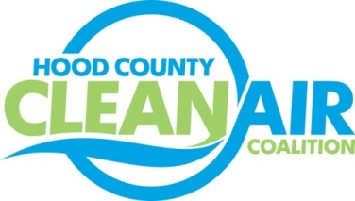
Meeting: Thursday, June 1, 2017
Neely House
304 East Rucker Street, Granbury, Texas 76048
8:30-10:00 a.m.

Agenda

- Call Meeting to Order
- EPA Updates – Randy Pitre
- Regional Updates – Michelle McKenzie
  - Regional Air Quality Update
  - Air North Texas Clean Air Action Day on June 23, 2017 www.airnorthtexas.org/cleanairactionday
  - Air Quality Funding Opportunities: www.nctcog.org/aqfunding
- Local Updates – Michelle McKenzie
  - Review of May Meeting Summary
  - Review of Projects
    - Monthly Budget Review for April
    - Status of Projects FY 16/17
  - Reports
    - May Ozone Update
    - Air North Texas Meeting
  - Annual Minutes
5) Other Discussion
- Adjourn

